# VIRTUALIZATION BY INSTALLING TYPE-2 HYPERVISOR

**STEP – 1:**

Create a new virtual machine.

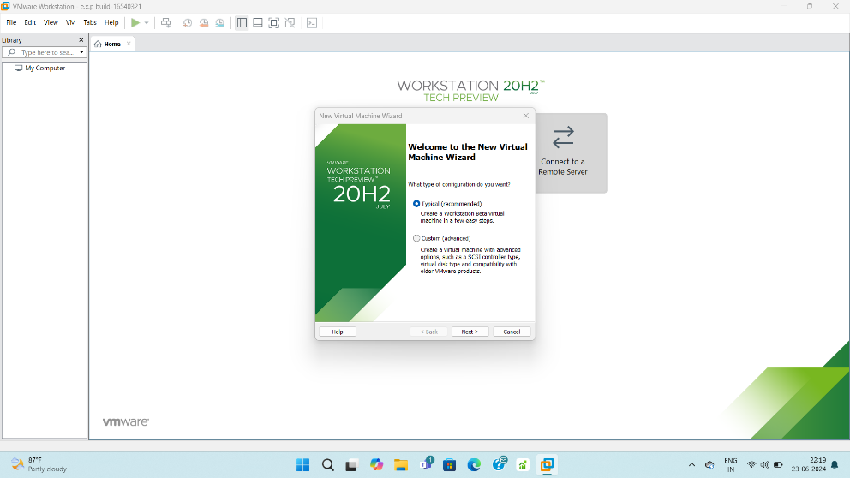

**STEP – 2:**

Using iso create VM.

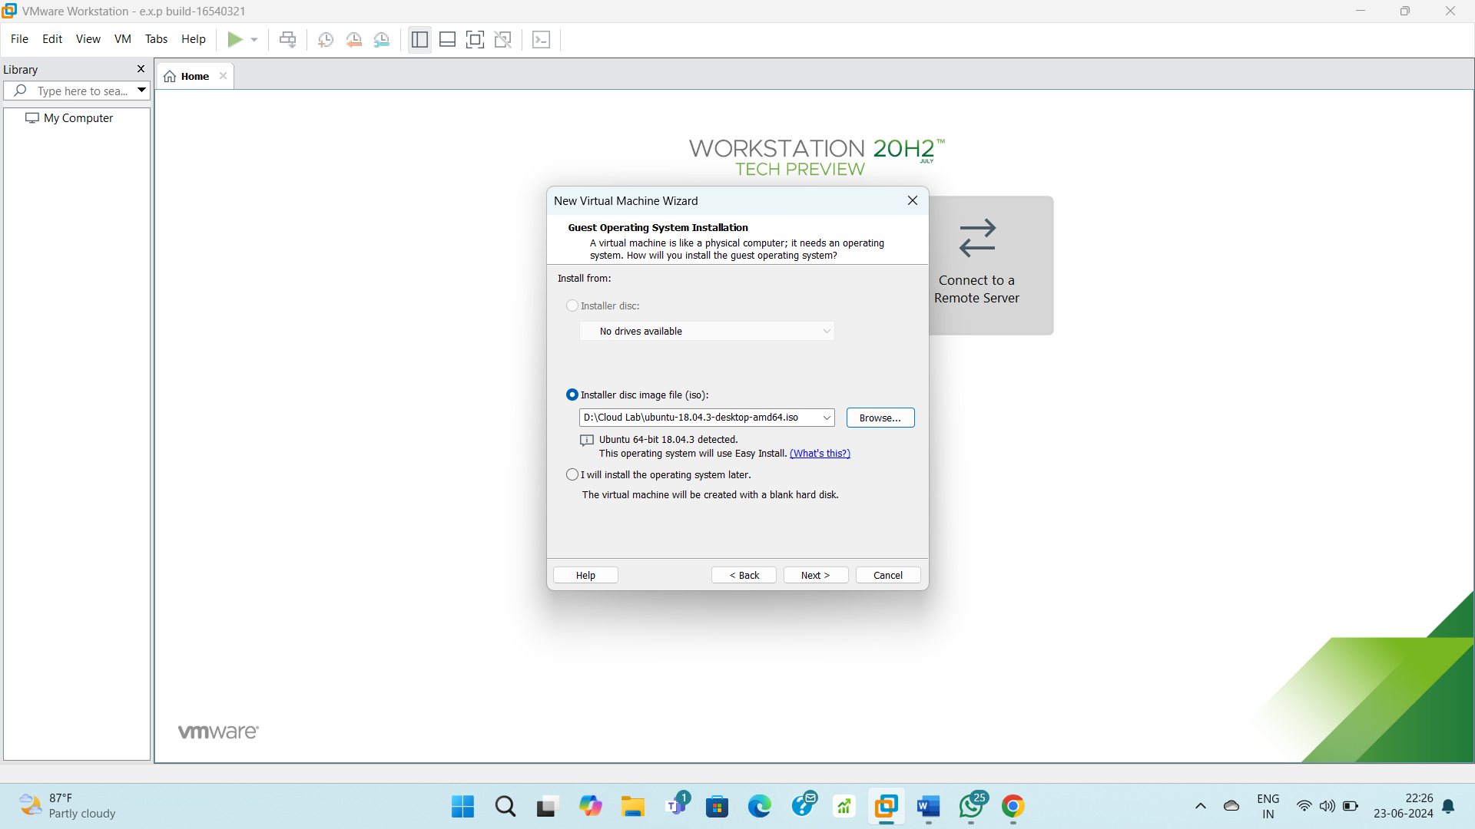

**STEP – 3:**

Give username and password details.

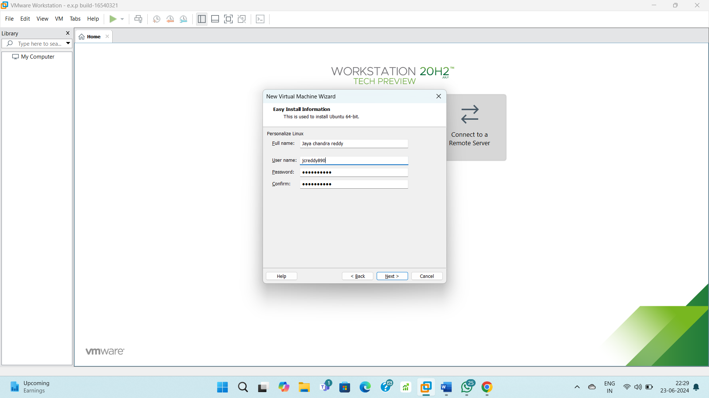

**STEP – 4:**

Give virtual machine name.

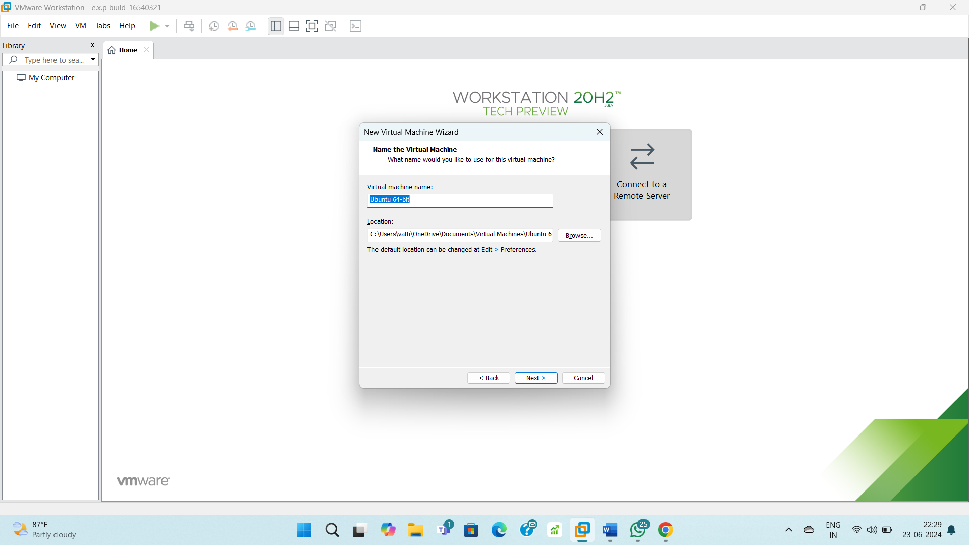

**STEP – 5:**

Allocate some disk storage to the guest OS.

